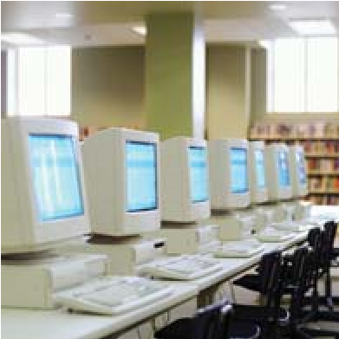
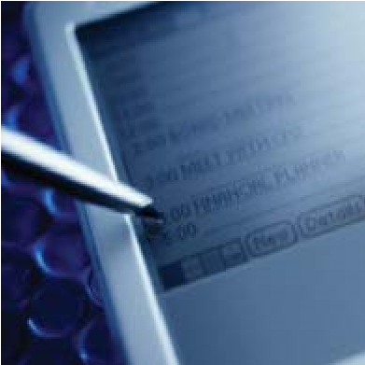
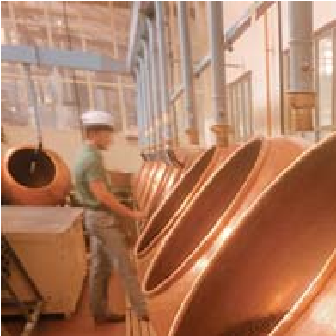
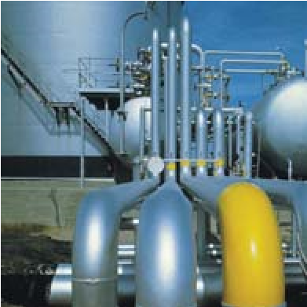
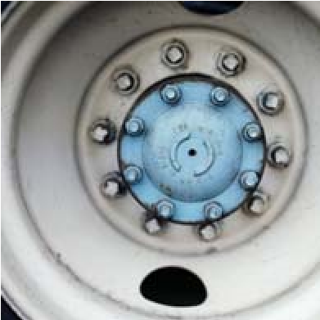
MRO Software Worldwide Support Services
Annual Report
Striving for Excellence
Table of Contents

What Our Customers Are Saying………………………………………………………………. 2

Message to the Customer ………………………………………………………………………… 3

The MRO Software Difference …………………………………………………………………. 4
About This Report ……………………………………………………………………………………. 5

2004 NorthFace ScoreBoard ℠ Award Winner …………………………………………. 6

Report from Independent Auditor …………………………………………………………… 7

About MRO Software Worldwide Support Services …………………………………. 8

Customer Satisfaction Results …………………………………………………………………. 9-10

Year – Over – Year Satisfaction Trends ……………………………………………………. 11

MRO Software Worldwide Support Services Organization ………………………. 12

Worldwide Support Services Infrastructure ……………………………………………. 13

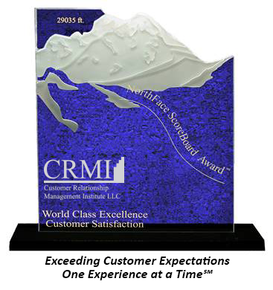
Customer Relationship Management Institute LLC
285 Billerica Rd, Suite 104
Chelmsford, MA 01824
(978)710-3278 Main
www.crmirewards.com

2
“In 20 years of project management, I have not seen better vendor technical support, MRO Software Services been a key part of the high success we are now enjoying…we completed a totally smooth deployment of MAXIMO 4 and a later upgrade to MAXIMO 5.”
Martha Casad, Capgemini Energy

What Our Customers Are Saying…
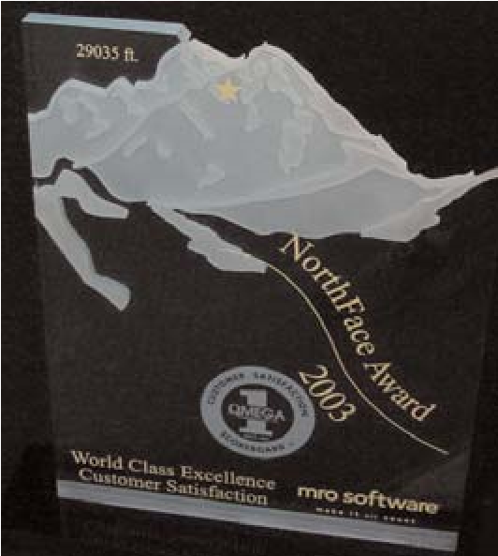

“I want to thank the MRO Software Support Services organization for their help. MRO Software has been very patient and methodical… and it really paid off because they resolved the issue we were having. Thanks again for providing excellent technical support!”
- Martha Casad, Capgemini Energy

“Duke Energy has been a Premium Support customer of MRO Software for over 2 years. Premium Support has provided excellent responsiveness and thorough resolution of our MAXIMO and MAXIMO PeopleSoft Interface issues during this time...with Premium Support and Standard Support, the MAXIMO product line has been very well supported by MRO Software.”
- Van Turner, Duke Energy
“Many thanks to the Actuate Support team at MRO Software. These individuals have worked with us, solving multiple issues over many hours and provided the highest level of support and training that I have ever seen within a call center.”
- Kelei Turner, Lockheed Martin 3Aero
3

“The MRO Software Support staff is great. It is a real pleasure to find such highly customer focused professionals working with us.”
- Paul Harris, Yallourn Energy Ltd.
“Through the use of MRO Software Support Services, LCRA has been able to reduce the cost
incurred with technical systems’ analysis by 200%.”
- Clay Cook, Lower Colorado River Authority

Message to the Customer
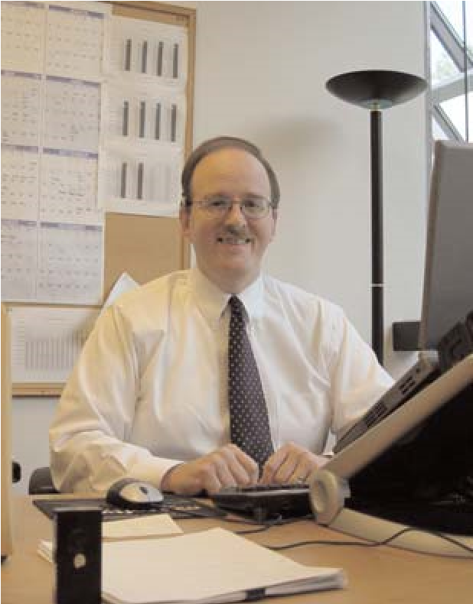
Dear MRO Software Customer,
Since the inception of MRO Software 36 years ago, it has been our mission to deliver the highest quality of service to our valued customers. At MRO Software, Striving for Excellence is more than just a motto; it is a way of life. Working in conjunction with Customer Relationship Management Institute LLC (CRMI), an independent quality auditing company, we built a program intended to capture your feedback about the delivery of our services. The purpose of the program is two-fold: to illustrate to us where we are performing well, and more importantly, to recognize where we are
Patrick McHale  Vice President  Worldwide Support Services MRO Software | not performing to your expectations, so we can take corrective action.  Based on much of the initial data we received, we are meeting the expectations of our customers. However, in our constant pursuit of excellence, we did not just want to meet your expectations, but rather exceed them. And while we certainly appreciate positive feedback from our clients, we also strongly value feedback regarding those areas where we can use some improvement. We use this input to immediately address any opportunities for improvement, and to drive our future objectives.
I sincerely thank those of you who participated in the surveys. Your suggestions and criticisms are what help us better understand the challenges you face, and the areas in which we can further differentiate ourselves from other support organizations. Thank you for your loyalty. We look forward to making considerable strides in providing you with the best level of support possible.
Sincerely,
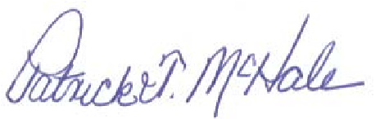
Patrick McHale
Vice President, Worldwide Support Services
MRO Software
4

The MRO Software Difference
MRO Software’s Strategic Asset Management solutions encompass all classes of assets in a single analytical model to measure their real-time performance across the enterprise. We are up to the challenge because we understand advanced technology and thanks in large part to the experience of 260,000 end users, we have learned how to solve a myriad of asset management problems. We have the software engineering and the understanding of business processes needed to help organizations measure asset performance, monitor their supply relationships and gain competitive advantage.
MRO Software runs deep in asset life cycle management expertise. Over many years, we have built an understanding of the unique needs of different asset classes and the unique needs of the different businesses that deploy them. No other company offers this broad, in-depth expertise across asset classes; this is important because it is essential to developing the business and performance measurement capabilities customers need to manage their assets. We understand these processes.
World-Class… Worldwide
One of the strengths of MRO Software is our Website Support Services organization – then men and women responsible for actively responding to customer queries and maintaining customer satisfaction customer satisfaction. They bring unparalleled expertise and successful completion to any task. Thoroughly versed in and comfortable with the demands of mission – critical asset management pertaining to the MAXIMO suite of products, they provide the world-class and worldwide – support our customers expect and deserve.

5

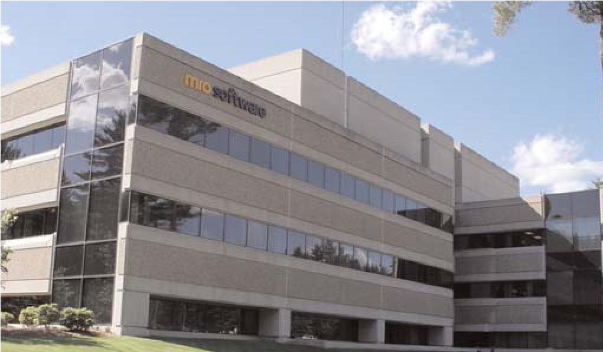
MRO Software has been building its international organization for many years. As a result, we don’t just provide a technically scalable solution, but all of the necessary support to produce results on a global basis.
In working with customers, partners and other IT specialists, MRO Software support professionals demonstrate on a daily basis the spirit of collaboration that infuses the entire company. The culture of MRO Software is one that welcomes the knowledge and ideas that others can bring to creating the best possible solutions for customers. The members of our senior management team measure their tenure in decades, not years.
MRO Software (NASDAQ: MROI) is a global company based in Bedford, Mass., with approximately 900 employees, 10,000 customers and more than 260,000 end-users. The Company markets its products through a direct sales organization in combination with a network of international distributors. MRO Software has sales offices throughout North America, Europe, Asia-Pacific and Latin America. Additional information on MRO Software can be found at http://www.mro.com.

About This Report
MRO Software commissioned an independent, quality auditing firm, Customer Relationship Management Institute LLC (CRMI) to benchmark customer perception of MRO Software Worldwide Support Services process, customer loyalty and overall satisfaction.

Demographics
One thousand MRO Software customers in more than 20 countries were contacted quarterly via telephone to determine their level of satisfaction with MRO Software’s products and support worldwide.

Methodology
Data was collected by randomly calling customers who use MRO Software’s products and services. Respondents were asked, in their local languages, to rate corporate-wide categories including New Client Perceptions, Service Process, Overall Services Satisfaction and Customer Loyalty. To determine customer loyalty, respondents were asked if they were willing to be a reference for MRO Software’s products and services. Respondents were also asked what the most important issue MRO Software was could improve upon. This data was obtained via a standard survey that included both multiple choice and open-ended questions.

Scale
Respondents were asked to rate their satisfaction with MRO Software’s products and services by using a scale from 1.0 to 5.0 (1.0 representing “does not meet expectations at all” to 5.0 representing “exceeds expectations”).

Rating System
The results were presented in two standard measuring methodologies. The first was percent satisfied and the second was weighted average. The purpose of the two rating methodologies was to provide the MRO Software Management Team with both percent satisfaction, the traditional method of measuring satisfaction, and weighted average, used to help the organization to exceed customers’ expectations.

Percent (%) Satisfied (Sat.)
For each question, the percent satisfied was calculated by summing the respondents’ answers for each of the scales (5, 4, 3) then dividing the answer by the total number of respondents.
6

Customer Relationship Management Institute LLC
285 Billerica Rd, Suite 104
Chelmsford, MA 01824
(978) 710-3278 Main Tel / (978)710-3381 FAX / www.crmirewards.com
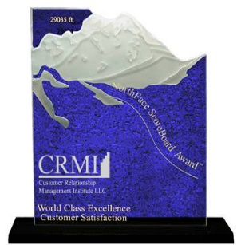  Congratulations!!  MRO Software Inc.  Awarded NorthFace ScoreBoard Award  The NorthFace ScoreBoard Award is presented annually by Customer Relationship Management Institute LLC (CRMI) to organizations who not only offer exemplary service to its customers but also who center their existence on a deep commitment to exceed all customer expectations. The customer-centric vision is to create a customer culture around the principles of respecting, empowering and trusting in others. It is a widely accepted truth that customer-centric organizations foster individuals who have a sense of mission about their lives and their work.  The year-long process begins each calendar year in January and closes in late December. At that time, the customer satisfaction scores are tallied and the winners are announced in late January. Winners of the awards are then publicly recognized by CRMI in press release articles to the trades. This year nearly seventy-five companies, representing many industry segments, were judged across the United States. This wide spectrum of high technology companies' customer satisfaction scores were reviewed and evaluated for exceeding customer expectations. Categories included were technical support, field service, account management and training. The evaluation method used by CRMI is the weighted average score for the above calendar year.  The first criteria in the nomination process is scheduled periodic measurement of customer satisfaction. Additionally, customer service organizations must achieve a four point zero or above out of a possible five-point zero score in any of the categories. Our market research indicates that these organizations that consistently achieve a four point zero or above are building customer loyalty. This is the level that significantly raises the bar on competitors. The candidates included companies who are innovators and pioneers in implementing tools and processes that exceed customers’ expectations  .  We chose Mount Everest to symbolize our award because we believe that the enormous effort required to conquer the world’s most difficult mountain compares favorably with the effort required to achieve world-class customer service. The CRMI NorthFace ScoreBoard Award proudly salutes, supports and recognizes those organizations with the courage of their convictions, those with the courage to “do the right thing” to exceed customer expectations.  We again congratulate MRO Software for its outstanding achievement.  Sincerely,  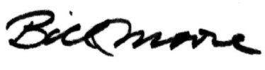  Bill Moore  Chief Customer Officer  CRMI LLC  7 | Mount Everest -  The North Face  Just the Facts  Elevation:  29, 028’; five miles up; the world’s highest summit is at about cruising altitude of a jet  Local Names:  Sagarmatha (Nepal)  Chomolungma (Tibet)  First Ascent:  1953, Sir Edmund Hillary, NZ and Tenzing Norgay, Nepal  Because it’s there:  In 1924, George Mallory and  Andrew Irvine, GBR, were last seen going strong for the top. It is unknown if they reached the summit before disappearing.  First Oxygenless Ascent:  1978, Reinhold Messner & Peter  Habeler, AUS  As good a reason as any:  “Expeditions are good spacers -- time and distance for  weighing and evaluating life back home as well as beginning to  understand somewhere new.” --  Pete Boardman, “Everest the Hard Way”

Report from Independent Auditor

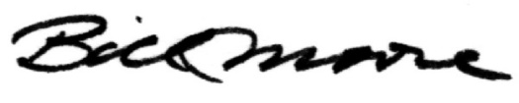

CRMI
December 31, 2004
Report of Independent Survey Auditors
We

have audited the customer base of MRO Software, through
December 31, 2004. These customer survey statements are the result
of our independent survey of customers. Our responsibility is to
express an opinion on these customer satisfaction statements based on
our survey audits.
We

conducted our customer survey audits in accordance with generally
accepted survey auditing standards. Those standards require that we
plan and perform the customer survey audit to obtain reasonable
assurance about whether the customer satisfaction statements are free
of material misstatement. An audit includes examining evidence
supporting the statements and disclosures regarding the quality of
service provided and the overall service satisfaction. We believe that
our survey audit provides a reasonable basis for our opinion.
In our opinion, the customer satisfaction statements in this report,
present fairly, in all material respects, the customer satisfaction position
of MRO Software, as of December 31, 2004 with our generally
accepted customer satisfaction survey principles.
Bill Moore
Chief Customer Officer
CRMI LLC.
Chelmsford, Massachusetts

CRMI LLC
Chelmsford MA 01824
285 Billerica Rd, Suite 104
104
(978) 710-3278
BbBbb

8

About MRO Software Worldwide Support Services

MRO Software Worldwide Support Services works closely with MRO Software’s Products & Technology and Quality Assurance divisions. With MRO Software Worldwide Support Services, our customers can take advantage of the following:
- Quality Service – including industry best practices, product knowledge and technical expertise
- Real-time Access – unlimited 24 x 7 via email or toll-free phone
- MRO Software Support Online – unlimited use of Support Online (http://support.mro.com) which contains our user forums, knowledge base articles, technical bulletins, periodic patches, maintenance releases and upgrade information
- eServices – allows users to create a new Service Request with Technical Support and view and append existing Service Requests. eServices is a real-time system; new Service Requests and updates are immediately available to Support personnel
- Access to the Software Developer Center – which consists of MAXIMO portlets, Entity Relationship
Diagrams, the ability to view audit tables and many other ways to extend MAXIMO functionality

Service Options
Find out which level of support is right for your business.
Standard Support
- Unlimited 24 x 7 toll-free “follow the sun”
Customer support
- Unlimited use of Support Online with eServices
- User forums
- Knowledge base
- Technical bulletins
- Upgrade information
- Defect listing by version
- Support lab for problem resolution
- Periodic patches, maintenance releases and upgrade to general releases
- Access to the Developer Center through Support Online
Premium Support *
- Named support contact – support account management – client provides up to 5 named contacts
- Priority issue escalation
- Priority routing for bug resolution
- Priority invitation to the MRO Support Advisory Council (MSAC)
- Quarterly conference calls
- Quarterly activity report
- Yearly site visit
- Proactive announcements and documentation
- Client environment replicated in out support lab
- Beta software availability

* Additional costs may be incurred with Premium Support

9
CRMI
ScoreBoard

Customer Satisfaction
NEW CLIENT SURVEY RESULTS

Category: Service Process Base: Worldwide  Questions  Please Rate MRO Software | # of Responses
 |  | Exceeded/Met  Expectations | Below Expectations
 |  | % | %
1. Overall experience with MRO Software Sales staff/consultants | 154 | 93% | 7%
2. Overall experience with MRO Software Worldwide Support Services | 144 | 91% | 9%
3. Overall experience with MRO Software Customer Response Center | 132 | 92% | 8%
4. Overall experience with MRO Software Professional Services | 105 | 92% | 8%
TOTALS | 535
 |  | AVG.  92% | AVG.  8%
Ratings legend:
Exceeded/Met Expectations
Below Expectations
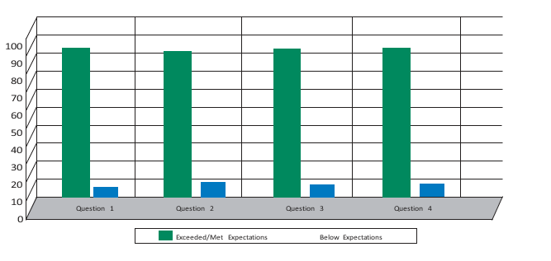
10
CRMI
ScoreBoard

Customer Satisfaction
TRANSACTION SURVEY RESULTS

Category: Service Process Base: Worldwide  Questions  1.Please Rate MRO Software Worldwide Support Services | # Responses | Exceeded / Met Expectations | Below  Expectations
 |  | % | %
 | 766 | 93% | 7%
2. Professional attitude and courtesy | 765 | 95% | 5%
3. Length of time you waited for initial response | 764 | 85% | 15%
TOTALS | 2295
 |  | AVG.  91.5% | AVG.  8.5%

Exceeded/Met Expectations
Below Expectations

Question 3
Question 2
Question 1
100
90
80
70
60
50
40
30
20
10
0

11
Year – Over – Year Satisfaction Trends
Performance Metric | Q1 04 | Q2 03
Technical Support Organization
Responsiveness of resolution provided | 3.5 | 3.1
Effectiveness of resolution provided | 3.5 | 2.9
Timeliness in providing the resolution | 3.4 | 2.6
Customer Response Center
Ability to resolve issues | 3.7 | 3.9
Timeliness in resolving issues | 3.5 | 3.1
Worldwide Support Services
Being flexible and east to work with | 3.5 | 3.1
Treating clients as long-term, valued customers | 3.7 | 3.1
Experience with MRO Software as a whole | 3.6 | 3.2

MRO Software Customer Loyalty
ScoreBoardSM

Service Process Satisfaction (Worldwide)
93% of MAXIMO® customers renew their licenses annually; a clear indication that MRO Software Worldwide Support Services adds value, not just during the initial installation, but on a continuing basis, through 24/7 access, responsiveness and quick resolution of problems.
Percent satisfied was determined by combing the total number of responses in the categories of exceeded expectations, performed above expectations and met expectations.

12

MRO Software Worldwide Support Services Organization
Providing quality service is not just good business practice, it is the reason MRO Software exists. When you buy our products, you place your trust and confidence in our technology and engineering. Our commitment to excellence begins with you. Along with every MRO Software product purchase comes a world-class, state-of-the-art organization dedicated to assisting your organization in optimizing the value of your product. Our customer assurance team is comprised of individuals who are dedicated to you and, as a team, strive to anticipate your needs and exceed your expectations.
13
Support Training
Quality Assurance
Internet Services
EMEA
Support Center
Premium Support
Asia-Pacific
Support Center
Customer Response
Center
Renewals &
Reporting
Development
Infrastructure
Support
North America
Support Center
Customer
Care
Technical
Support
Support
Operations
Engineering
Support
Maintenance
Renewals
Worldwide Support Services
Latin America
Support Center

Worldwide Support Services Infrastructure
At MRO Software Worldwide Support Services, “Striving for Excellence” is our goal to provide you with the highest quality of support. Our support services organization is committed to providing world-class technical support for our entire suite of products in a timely and proficient manner. MRO Software Worldwide Support Services consists of a dedicated, multilingual staff of professionals trained in maximizing customer value by delivering effective technical solutions. If required, the global support infrastructure escalates issues to the appropriate support center for resolution, while retaining local management of your call within your regional area. Available 24 hours a day, 7 days a week, our support staff is here to understand our customers’ business needs and help you make the most of your technology investment.
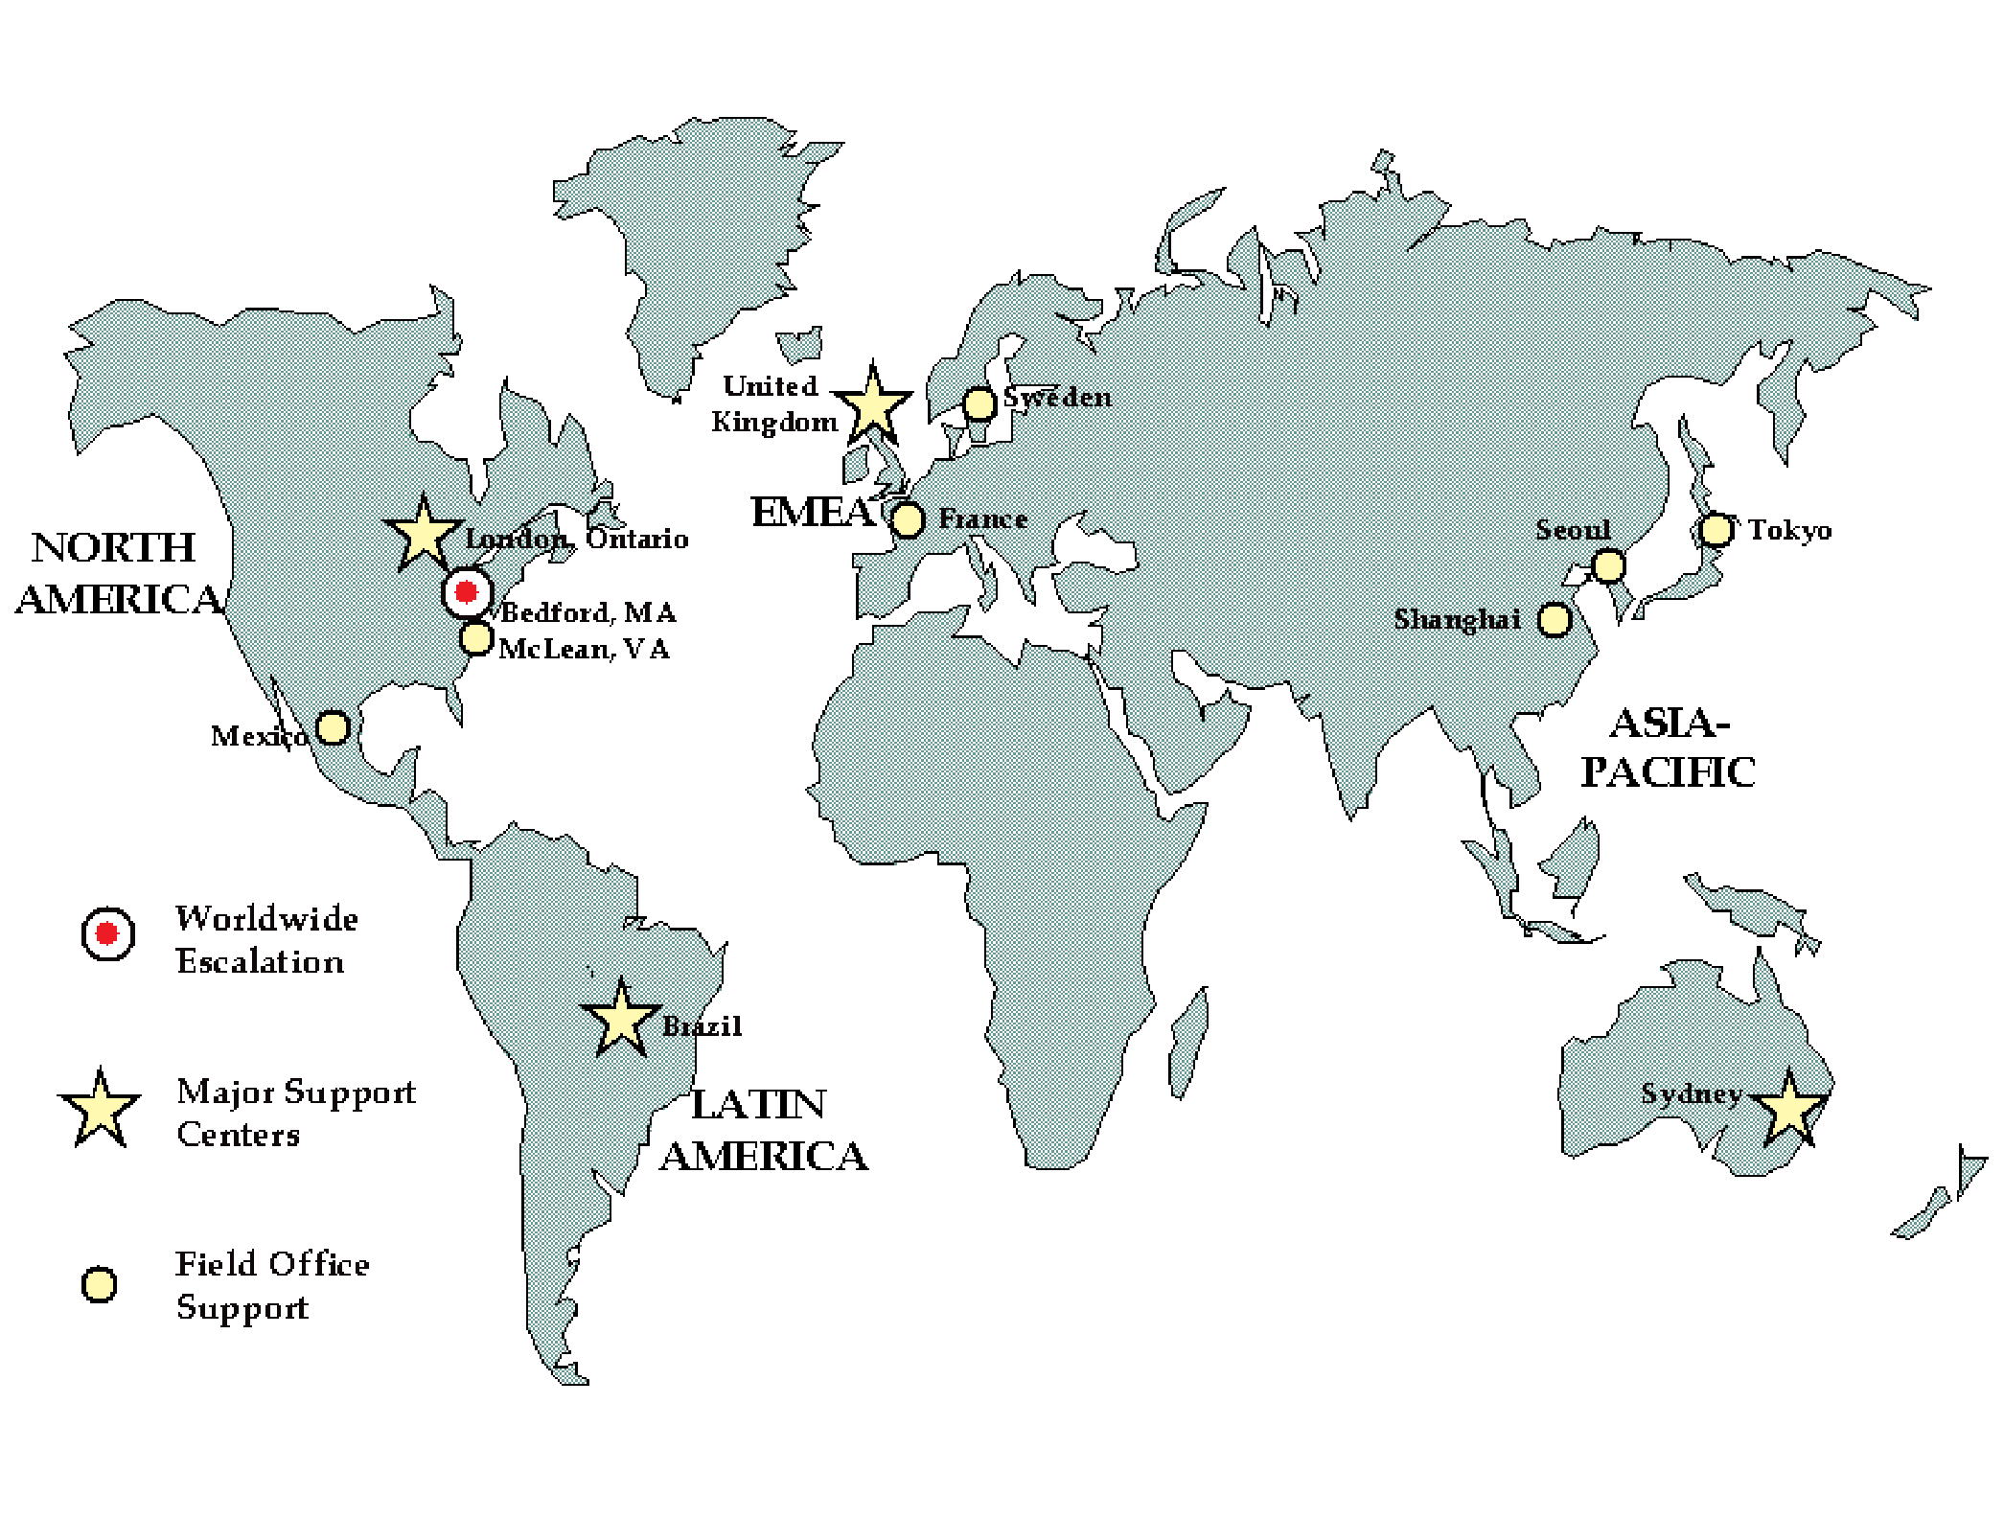
14

