Employee Engagement 360
Easy as 1-2-3

Raise Your Employee’s CX Relationship Skills
CX Operational Practices- CX Awareness – CX Commitment
1 | Employee Soft-Skill Certification Training
The CXDNA Playbook Strategy identifies Employee Engagement as a critical component to implementing worldwide CX strategy and soft skills certified training to provide the foundation for delivering consistent exceptional customer experiences (CX).  CEMPRO (Customer Experience Management Professional) is an online interactive training in customer relationship skills building for customer facing professionals and others. The course includes online testing with certification for employees who meet the criteria of a minimum test score of eighty (80%) percent. Companies may choose to participate in the annual CEMPRO Award recognition program that includes marketing rights in all print/electronic media.  The CEMPRO course includes four (4) interactive – certified testing modules:  Customer Care / Dealing with Difficult Customers / Problem Solving Skills / Time Management |  |  |  |  |  | 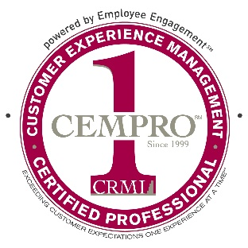  Employee Certified Training
2 |  | Employee 360 Alignment Survey
Employee engagement must include conducting a 360 Employee Alignment Survey(eas360) with your customer-facing groups comparing their “perception” of the level of customer satisfaction/loyalty with their services vs. the “actual” customer ratings. The results of this alignment provide for an important insight into customer views and actively engages your employees to provide consistently exceptional customer experiences. Survey categories may include satisfaction with company – sales – marketing – training – service and competitive benchmarking. Companies may choose to participate in the annual NorthFace ScoreBoard (NFSB) Award for world-wide superior customer service that includes marketing rights in all print/electronic media. |  |  |  |  | 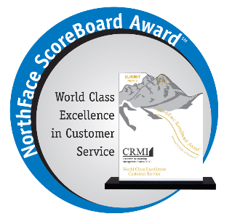  Customer Satisfaction
3 |  | Employee Recognition and Satisfaction
The Employee Recognition Program (ERP) strategy uses a 5-point weighted average point system to identify employees who are exceeding customers’ expectations and is integrated to any Voice of the Customer (VOC) satisfaction survey program which rate employees’ customer satisfaction performances. This approach eliminates the traditional employee complaints of subjective management goals. The ERP strategy establishes a monthly frequency with a 4.0 as the minimum overall customer satisfaction rating to be recognized as exceeding customer expectations. Recognition may include various forms such as cash bonus, television, vacation resort, gift certificates and others.  Additionally, companies may choose to participate in the annual NorthFace ScoreBoard (NFSB) Award for employee satisfaction based on the company’s benefits – career opportunities – employee training - commitment to making CX the most critical component of company’s DNA. The NFSB Employee Satisfaction Award, uses a 5-point weighted average point system to identify companies who meet the minimum employee satisfaction rating of a 4.0 criteria, includes marketing rights in all print/electronic media. |  |  |  |  | Cash bonus  Television  Vacation resort  Gift Certificate
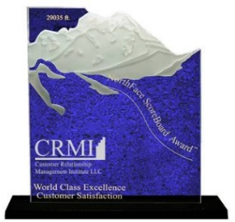
Employee Satisfaction

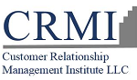  Exceeding Customer Expectations - One Experience at a Time℠ |  |  | CRMI is your Customer Experience Management (CEM) partner. Empower your organization with the knowledge and training for delivering the ultimate customer experience. Build loyalty, drive revenue and maximize client satisfaction with a proven CXDNA Playbook Strategy.  Ph: 978-710-3278 | Email: drivera@crmirewards.com | Website: www.crmirewards.com

