Our Customers Report Card is in - They have Rated Our Employee Training #1

CEMPRO AWARD
Advertisement Draft

This Photo by Unknown Author is licensed under CC BY-SA-NC
CXDNA REPORT CARD | Exceeding Customer Expectations – One Experience at a Time ℠
CEMPROCFG RATING
95%
Overall % Satisfaction
Service
99%
Overall ScoreBoard
Index Service
4.9/5.0 max
Ranked highest in
Customer Service
6 years
Overall Employee Communication / Professionalism
4.9 / 4.5

Customer Satisfaction Survey Results by Question - Customer Support 2018
Customer Support Group  Satisfaction Questions: | CURRENT YEAR |  |  | PRIOR YEAR
 | Response | Sat% | ScoreBoard Index (SBI) | Response | Sat% | ScoreBoard Index (SBI)
Time to respond | 16137 | 99% | 4.9 | 11432 | 99% | 4.8
Time to resolve | 16137 | 99% | 4.9 | 11432 | 99% | 4.8
Engineer Knowledge | 16137 | 99% | 4.9 | 11432 | 99% | 4.9
Quality of Communication/Service | 16137 | 99% | 4.9 | 11432 | 99% | 4.9
Overall Satisfaction Support | 16137 | 99% | 4.9 | 11432 | 99% | 4.9
Total | 80685 | 99% | 4.9 | 57160 | 99% | 4.9
Loyalty Question: | NPS |  |  | NPS
How likely are you to recommend AJAX to a friend or colleague? | 89% |  |  | 91%

Customer Satisfaction Survey Results by Question - Consulting Services Group 2018
Consulting Group  Satisfaction Questions: | CURRENT YEAR |  |  | PRIOR YEAR
 | Response | Sat% | ScoreBoard Index (SBI) | Response | Sat% | ScoreBoard Index (SBI)
Consultant Knowledge | 181 | 95% | 4.6 | 234 | 98% | 4.4
Consultant Professionalism | 182 | 93% | 4.6 | 234 | 98% | 4.4
Consultant Responsiveness | 182 | 94% | 4.6 | 234 | 98% | 4.1
Consultant Overall Project Execution | 182 | 92% | 4.6 | 234 | 98% | 4.4
Project Manager Knowledge | 186 | 95% | 4.6 | 234 | 98% | 4.7
Project Manager Professionalism | 182 | 93% | 4.6 | 234 | 98% | 4.7
Project Manager Responsiveness | 181 | 94% | 4.6 | 234 | 98% | 4.7
Project Managers Overall Project Execution | 182 | 94% | 4.6 | 234 | 100% | 4.7
Overall Satisfaction with Services | 182 | 94% | 4.6 | 233 | 98% | 4.8
Total | 1640 | 94% | 4.6 | 2105 |  | 4.5
Loyalty Question: | NPS |  |  | NPS
How likely are you to recommend AJAX to a friend or colleague? | 90% |  |  | N/A

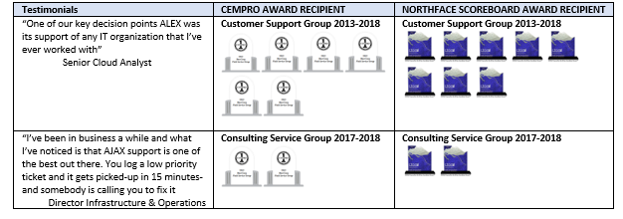

We AJAX Inc. hereby attest that the above is a true and accurate statement relating to the processing and to the survey results of our customer survey measurement process and for our employee soft skills training for the period of January 1, 2018 to December 31, 2018. Further, we understand that the employee CEMPROCFG training ratings and the NorthFace ScoreBoard (NFSB) Audit services ratings may result in our firm becoming a recipient of the awards based on the information we provided in this statement. Customer Relationship Management Institute LLC (CRMI) grants marketing rights, both electronic and print, including usage of award logo, Customer Bill of Rights tagline “CXDNA powered by NorthFace ScoreBoard Award”, Exceeding Customer Expectations - One Experience at a Time to all NFSB and CEMPRO recipients for the applicable calendar year. Lastly, we acknowledge the NFSB audit results require an annual minimum SB Index of 4.0 out of a possible 5.0 or equivalent rating system, based solely on our customer’s ratings, requires the survey results be made available to all stakeholders and requires a minimum of one (1) individual to be CEMPRO-Advocate certified.

AJAX Inc. Customer Relationship Management Institute LLC
|Date: |Date: 4/3/2019
John Smith Bill Moore
VP, Worldwide Support Chief Customer Officer - Auditor

