REPORT FROM INDEPENDENT CX AUDITOR | AJAX’S
To the Customers of AJAX  We have conducted our NorthFace ScoreBoard (NFSB) Audit and have conducted CEMPRO soft skills training for the calendar year 2018. This CXDNA Report Card is the result of our independent review of the customer satisfaction survey results provided by our client management personnel. Our responsibility is to express an opinion on these customer satisfaction survey results based on our audit.  Our NFSB audit includes a review of the company’s overall Customer Experience (CX) strategy as it compares to our CXDNA Playbook Strategy twelve (12) components. The results of the CX comparisons are included in our audit findings. Further, each client must provide individual (s) to be certified by our CEMPRO-Advocate training course that includes softskills training and our CXDNA Playbook strategy training as part of meeting the NFSB Award and CEMPRO Award criteria. Our NFSB audit produced this CXDNA Report Card containing a summary of the client’s survey results, executive message to their customers and several CXDNA links to their website. The CXDNA links are intended to provide additional information on the company’s CX program. The CXDNA Report Card is a vehicle for communicating the company’s CX program objectives and their results to stakeholders and the marketplace at large.  We conducted our customer satisfaction survey audit in accordance with our generally accepted survey auditing standards. These standards require that we review the customer survey results, to obtain reasonable assurance about whether the customer satisfaction statements provided are free of material inconsistencies. An audit includes examining the survey process, survey results, survey questions, survey frequencies and obtaining written verification from our client management personnel responsible for measuring customer satisfaction as evidence supporting the above examination. We believe that our NFSB audit provides a reasonable basis for our opinion.  In our opinion, the consolidated CXDNA Report Card presents fairly, in all material respects, the customer satisfaction position for the time period of January 1, 2018 through December 31, 2018.  Bill Moore  Chief Customer Officer  Customer Relationship Management Institute LLC  P.O. Box 323  Chelmsford, MA 01824-0323  978-710-3278 | www.crmirewards.com  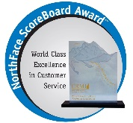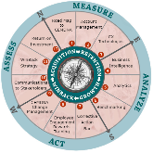 | OUR COMPANY WEBSITE  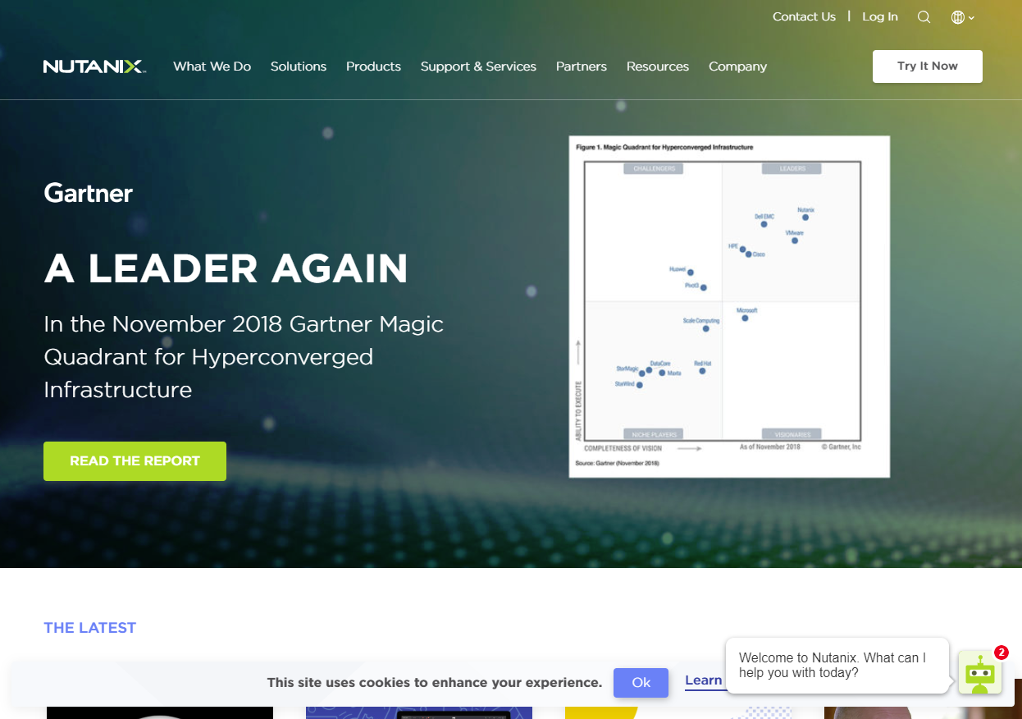
AWARDS
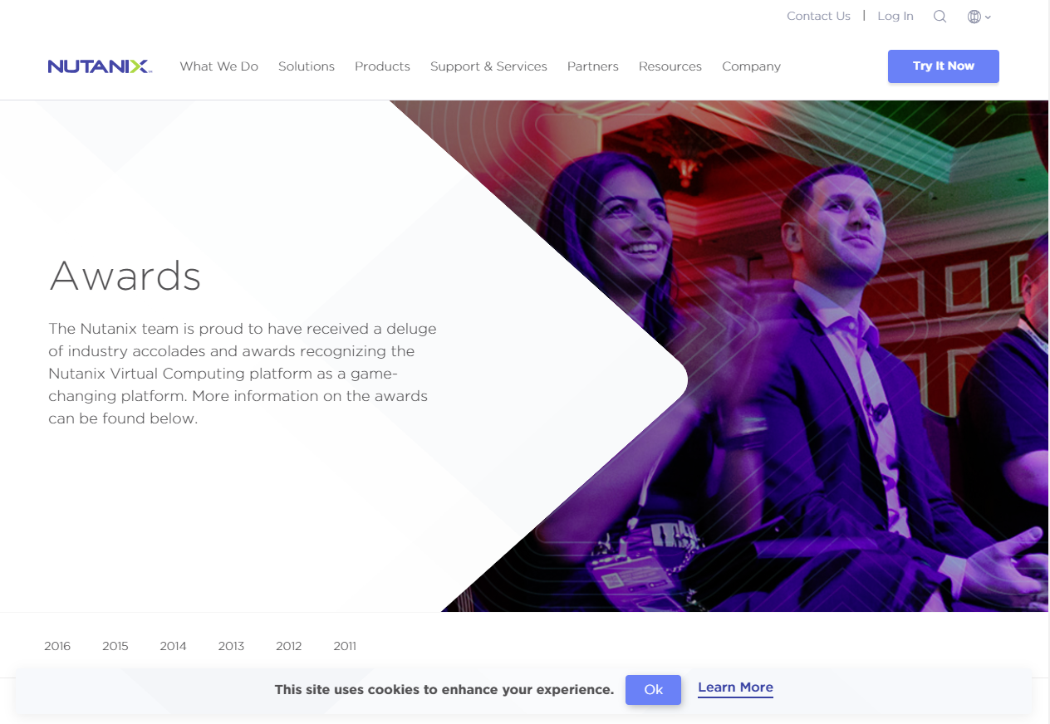

SERVICE ORGANIZATION
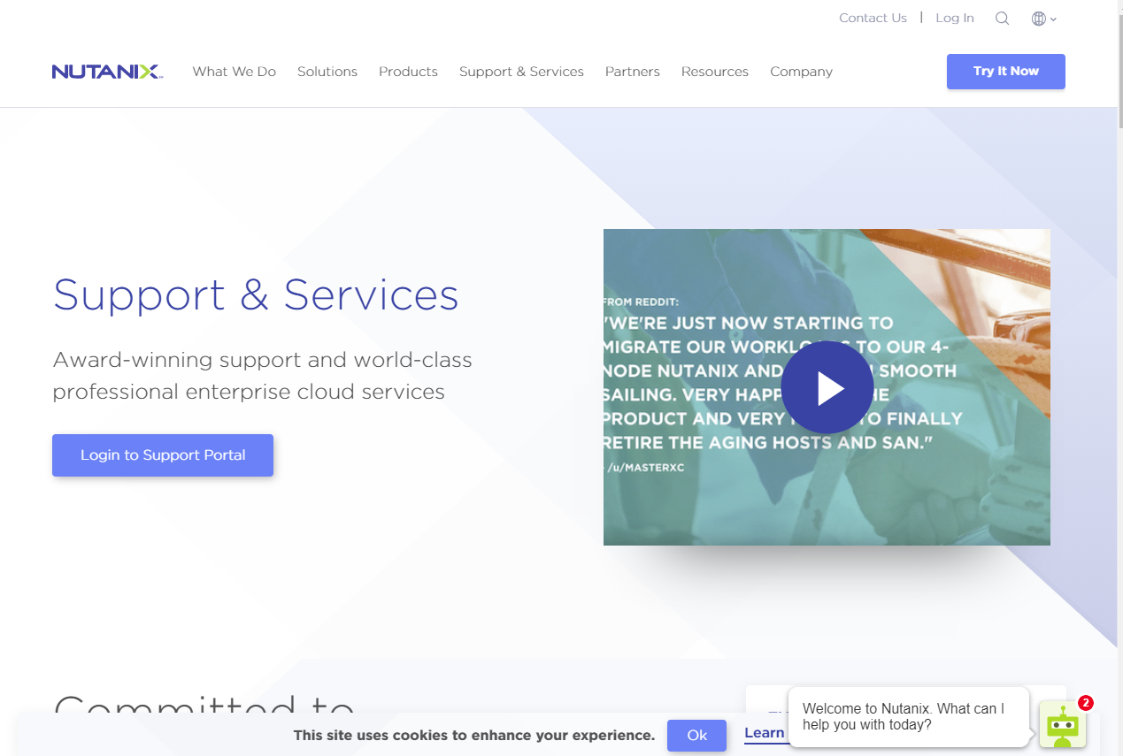

TESTIMONIALS
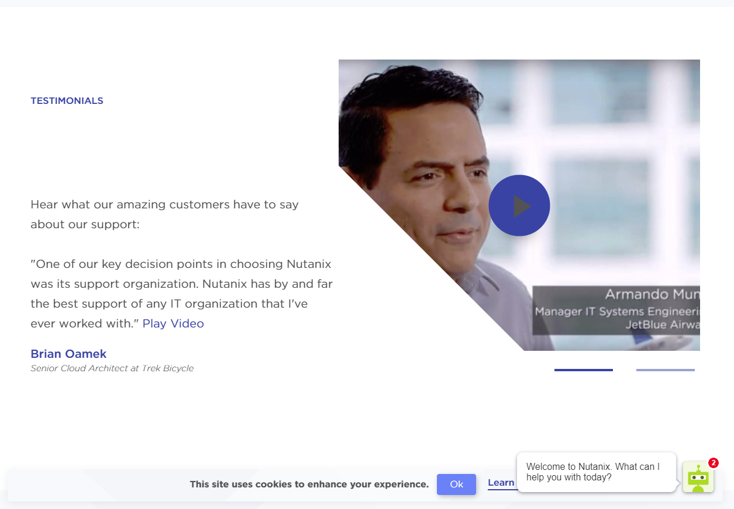

COMPANY OVERVIEW

DRAFT

Our Mission
Company name makes infrastructure invisible, elevating IT to focus on the applications and services that power their business. The networking into a resilient, software – defined solution with rich machine intelligence.

The Results
Predictable performance, cloud consumption models, robust security, and seamless application mobility for all enterprise applications at any scale. A single software fabric unifies your private and public cl ouds and delivers one-click simplicity in managing multi-cloud deployments. One OS. One click™

A MESSAGE FROM MANAGEMENT

DRAFT

Dear Customer

We implement our CX program to insure we provide goods and services that will consistently exceed your expectations. We realize to continuously exceed your expectations is an ongoing challenge –that we are pleased to accept.

We strive to provide our employees with a workplace that motivates, training to raise customer service awareness–competence–operational practices, where customers are valued, and relationships are maximized. We consistently recognize and reward our employees who exceed customers’ expectations. We consistently measure the level of customer satisfaction with our products/services. We consistently report the levels of customer satisfaction and measure our performance versus industry standards and/or best in class performances. We consistently provide corrective action to improve our performance in products/services. Our customers have been interviewed and the information gathered from these interviews has allowed management to make improvements necessary to retain and enrich the product/services provided to our customers.
This independent annual CXDNA Report Card summarizes our CX program results. We thank you for your participation and welcome your comments and the challenge of turning your comments into action. Our pledge is to continue to build on our CX program foundation of “listening to our customers” and to continuously make improvements, because, our customers satisfaction is the most critical component of our company’s DNA.

Sincerely,

John Smith

John Smith
Vice President Worldwide Support

CXDNA PROGRAM SUMMARY | CUSTOMER SUPPORT GROUP

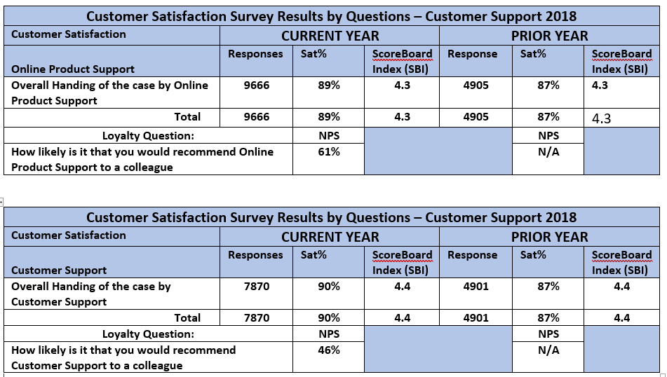

CXDNA PROGRAM SUMMARY | CONSULTING SERVICES GROUP

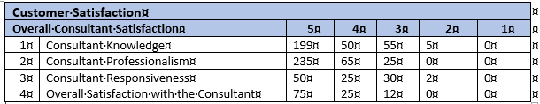

CUSTOMER SATISFACTION SURVEY RESULTS - 2018 | CONSULTING SERVICES GROUP
Satisfaction Questions: | CURRENT YEAR |  |  | PRIOR YEAR
 | Response | Sat% | SCOREBOARD  INDEX (SBI) | Response | Sat% | SCOREBOARD  INDEX (SBI)
Consultant Knowledge | 181 | 95% | 4.6 | 234 | 98% | 4.4
Consultant Professionalism | 182 | 93% | 4.6 | 234 | 98% | 4.4
Consultant Responsiveness | 182 | 94% | 4.6 | 234 | 98% | 4.1
Overall Satisfaction with Services | 182 | 94% | 4.6 | 233 | 98% | 4.8
TOTAL | 1640 | 94% | 4.6 | 2105 |  | 4.5
Loyalty Question: |  | NPS |  |  | NPS
How likely are you to recommend Company name to a friend or colleague? |  | 90% |  |  | N/A

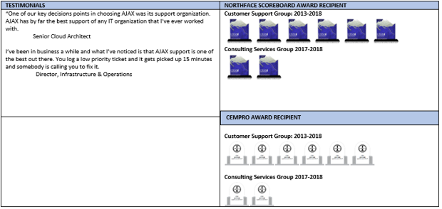

NORTHFACE SCOREBOARD AWARD | Customer Bill of Rights | Established – 1998
Adopt a Customer Bill of Rights reviewed and approved by Executive C-Level Management Team.
Article I:  Companies agree to provide goods and services that will consistently exceed their customer’s expectations. | Article VI:  Companies agree to adopt a change management strategy to consistently provide corrective action to poor performance in products and services.
Article II:  Companies agree to provide their employees with a workplace where employees are motivated, trained and skilled, customers are valued, and relationships are maximized. | Article VII:  Companies agree to consistently measure their performance versus industry standards and/or best in class company performers.
Article III:  Companies agree to recognize and reward their employees who consistently exceed their customer’s expectations. | Article VIII:  Companies agree to consistently validate their customer satisfaction results via being recipients of industry awards-certifications and/or independent audit of their customer satisfaction results.
Article IV:  Companies agree to consistently measure the level of customer satisfaction with a company’s product and services. | Article IX:  Companies agree to a chief customer advocate position, reporting to the President whose sole responsibility is the ombudsmen for customers, coordinates the corrective action plan/change management strategy and who consistently reports the level of customer satisfaction with products/services to the executive management team.
Article V:  Companies agree to consistently report levels of customer satisfaction for products and services to executive management and the enterprise. | Article X:  Companies agree to an annual review of their customer experience management strategy (CX) which must include Article I thru Article IX.

CXDNA PLAYBOOK STRATEGY BENCHMARK |  |  |  |  |  |  |  |  |  |  |  |  |  |  |  | CLIENT CX STRATEGY
 |  | COMPONENTS |  |  |  |  |  |  |  |  |  |  |  |  |  | Y = YES  N = NO  UNK = UNKNOWN
CXDNA Playbook Strategy |  | 1 | 2 | 3 |  | 4 | 5 | 6 | 7 |  | 8 | 9 | 10 | 11 | 12
Client Strategy |  | Y | Y | Y |  | UNK | UNK | Y | Y |  | Y | UNK | Y | UNK | UNK
CXDNA PLAYBOOK STRATEGY COMPONENTS |  |  |  |  |  |  |  |  |  |  |  |  |  |  |  | 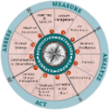
1. Road Map – CXDNA | 4. Business Intelligence |  |  |  | 7. Corrective Action Plan |  |  |  |  | 10. CX Stakeholders Communication
2. Account Management | 5. Analytics |  |  |  | 8. Employee Engagement |  |  |  |  | 11. WinBack Strategy
3. CX Technologies | 6. Benchmarking |  |  |  | 9. Change Management |  |  |  |  | 12. Return on Investment

