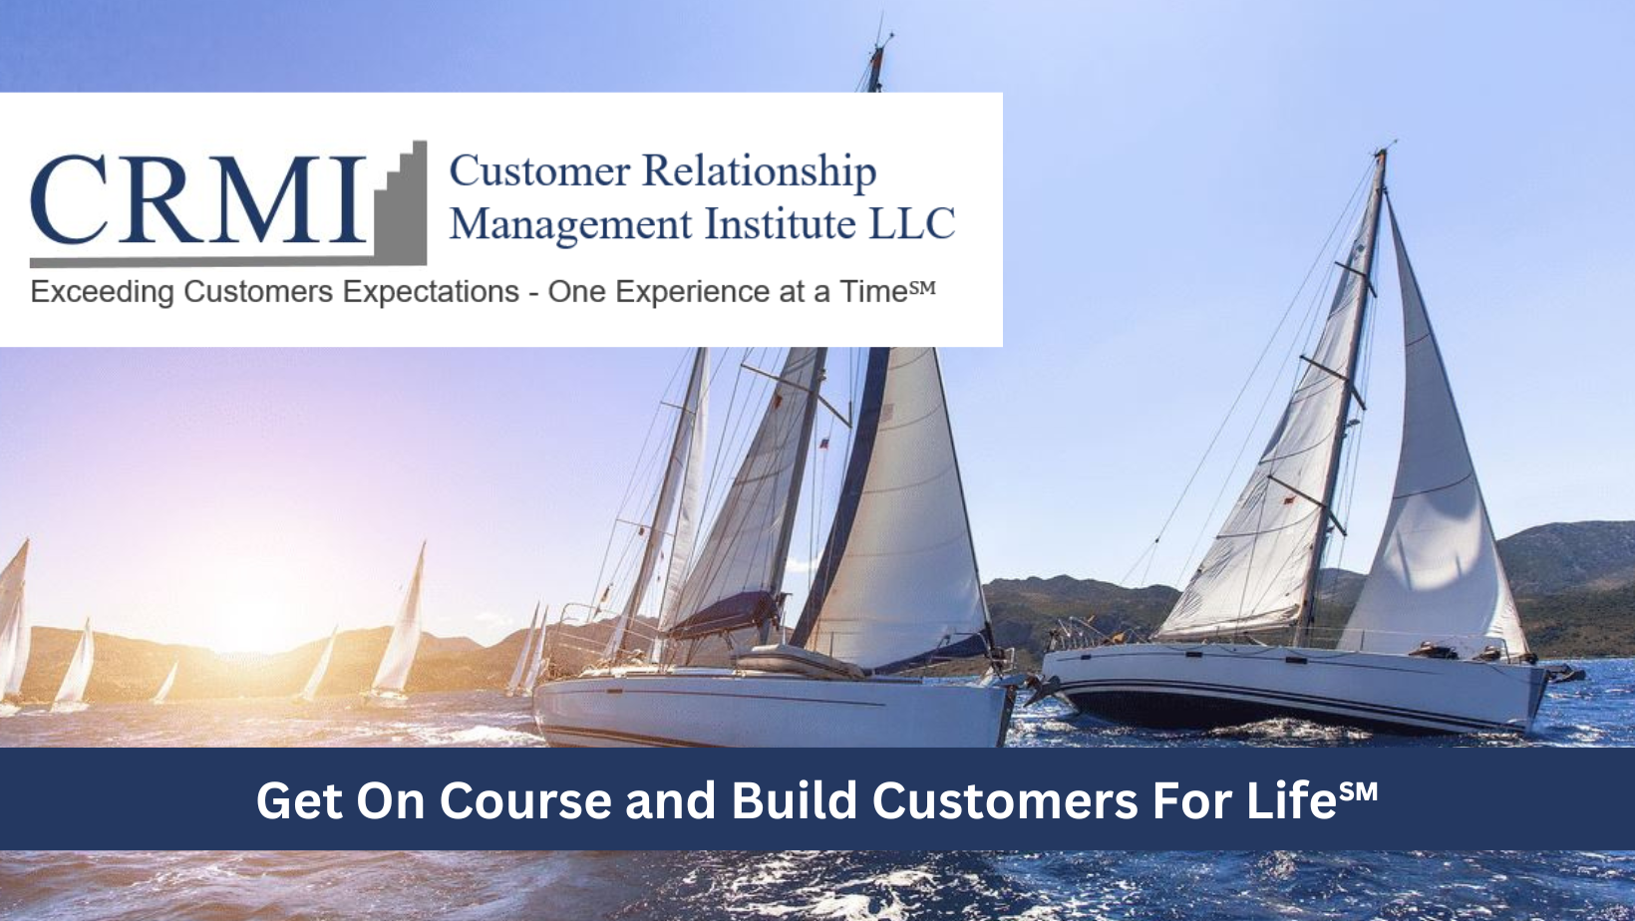

Set yourself apart from the competition through our CEM Stakeholder Communications Program

We'll give you the game plan to increase customer acquisition, retention, and growth, plus win back lost accounts.

Your company may have high marks in customer service, but if your stakeholders are not aware of your success then you're missing out on an opportunity to gain long-term customer retention and growth. Integrating a CEM Communications strategy into your marketing/sales plan will result in increased new account acquisitions – account retention – account growth and winning back lost customers.

Companies' marketing strategies typically focus on the features of their products/services and promote how they stand out above the rest. But every company is saying the same thing. So how do customers and prospects know who's really the best?

While product and price are important factors, especially to first-time buyers, the quality of service and support customers consistently receive is what makes the difference to decision makers everywhere.

So, let your stakeholders and prospects know how you excel in customer service through a compelling CEM Communications program. Let us show you how to design and implement a powerful CEM Communications strategy into your marketing programs.

See what the CEM Stakeholder Communications Program includes:

CEM Stakeholders Communications Program

 | Annual CXDNA State of Union Report  You may already distribute a public, financial annual report, but why not share one focused specifically on your CX strategy and results |  | Voice of the Customer Video  Have your top executive interviewed for a high-level look into your CX strategy and what you’re doing to keep customers loyal
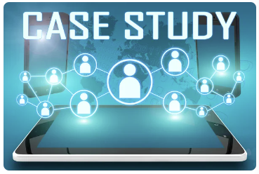 | CX Case Studies/Customer Testimonials  Let your customers shine a light on your success by sharing their own stories | 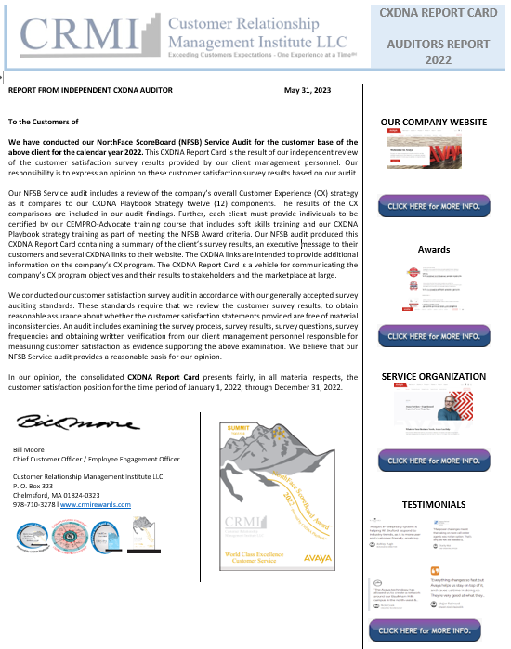 | CX Certified Report Card  Share with customers and prospects a third-party audit of your superior customer satisfaction data
 | Intelligent Visual Communications  Project your CX content in real time via dynamic multi-media LED dashboard displays and handheld devices |  | CX Infographic/Content Experiences  Depict your CX Strategy and how you serve your customers through an engaging, graphically-rich, online story AND interactive content experiences
 | Public Relations  Keep customers and prospects informed of your CX success through news releases, newsletters, white papers and more |  | Social Media  Capitalize on the power of LinkedIn, Twitter, Facebook and other social channels to tout your superior customer service
 | Live Video Streaming  Create an event that captures your CX story as it happens and reach your customers and prospects through today's most engaging medium |  | CX Podcasts  Participate in a podcast highlighting your CX story that customers and prospects can listen to at their convenience
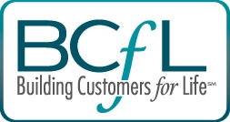 | CX Webcasts  Be a guest on one of our Building Customers for Life (BCFL) webcasts where you can share the keys to your CX success |  | Competitive Satisfaction/Loyalty Analytics  Drive your CX strategy and create measurable business impact through competitive satisfaction/loyalty analytics
 | Customer Events  Bring together customers and prospects to show your appreciation and to let prospective clients hear your success stories | 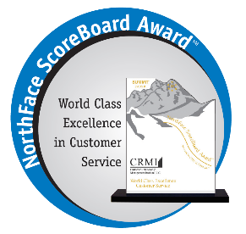 | CX Awards  Leverage North Face ScoreBoard Awards and other industry awards that recognize your customer service excellence/product excellence/employee excellence

Quick Start” Stakeholder Communications Audit

LEARN MORE ABOUT CRMI

Customer Relationship Management Institute LLC is a pioneer and recognized expert in developing and implementing customer experience management (CEM) strategy and employee experience management programs that lead to increased product/service revenues and profits. To learn more about this program contact us today at (978) 710-3269 / drivera@crmirewards.com.

