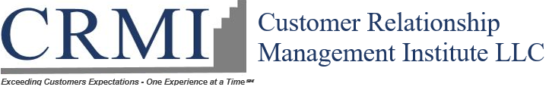 | 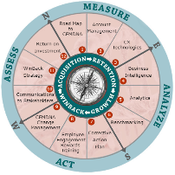

Building Customers for Life (BCfL) Webcast Series Schedule: 2019

January 28 |Embed Customer-Centricity in Your Company

Is customer experience CX a key component in your company's DNA? Understanding your maturity level will help you build out your long-term CX strategy. Join us on this webinar to start using the CXDNA Playbook Strategy to transform your company's CX from initiative to key strategy.
You'll learn how to:
- Integrate CX into your corporate culture, throughout all levels of the organization, to ensure long-term success
- Using Journey mapping to determine and prioritize which areas of customer experience you should focus on improving
- Optimize your customers moment of truth - and your high-value interaction - for the best outcome
- Select a name with impact to Brand your CX program among all stakeholders
- Create Customer Bill of Rights and published it everywhere – guide for employees’ action with customer

February 28 |Account Management Profile (AMP)

Customer profiling isn't just for personalized marketing messages. Using CX AMP based profile strategy that segments customers by value and title-base will improve business results.
Join us on this webinar to learn how to:
- Create value - and title-based segments that support your corporate CX in growth goals
- Segment and manage key accounts (e.g., tiers I, II, III) and key contact titles (e.g., decision makers, influencers) to optimize the customer relationship
- Implement relationship building strategies that will have key accounts viewing your organization as a valued added partner NOT A VENDOR
- Avoid Under and Over spending on service / support for different types of customers

March 21 |Selecting Your Ideal CX Technologies

What are the core CX Technologies available today? More important, what business problems and opportunities do they address?
Join us on this webinar to learn how to:
- Choose the right CX Technologies to support your CX strategies and goals
- Understand how different CX Technologies are best integrated to create an optimal CX Tech stack
- Learn how to measure the impact of CX Technologies; this includes empowering employees, streamlining processes, building business value and calculating your ROI.

April 25 |Benefiting from CX Focused Business Intelligence

CX leaders need business intelligence unique to their role, but don’t always get the data they should have to make informed decisions. Join us on this webinar to find out what to track and why.
You’ll learn:
- What data to include in your CX-focused BI dashboard
- The pros and cons of common BI reporting
- Understand different BI Technologies available – benefits – challenges

May 30 |CX Analytics as a Competitive Advantage

Does your organization consistently use CX-related analytics to provide a competitive Advantage? You do not need reams of data to get useful Insight on customer experience semicolon you need the right data. You also need the right metrics to ensure that you are tracking activities that will make the greatest positive impact on your organization.
Join this webinar to learn how to:
- Determine which CX metrics are the right for your organization
- Connect CX metrics to business metrics
- Link satisfaction and operational data
- Use CX-related analytics as a competitive advantage

June 27 |Benchmarking for CX success

If your organization isn't using benchmarking to develop KPI's and other CX Playbook Strategy components, even your best CX efforts will stall. Benchmarking your customer experience performance and the CX Playbook Strategies that support that are essential for long-term success. Companies can build and track internal and external benchmarks to get the most from benchmarking.
Join this webinar to learn:
- The most common CX benchmarking approaches: what are they and when do they work best?
- Top industry benchmarks: What are they and when should you use them?
- Custom benchmarks: How to build them and select actionable benchmarks?

July 31 |Boost Retention and Revenue with Timely Corrective Action Plans

Do your corrective action plans align with your Account Management Profile (AMP) segmentation? Address in real time the systemic issues the negatively impact the customer experience. Timely correct action is essential to ensuring customer loyalty and the positive revenue impact. Doing so can't be haphazard; there needs to be set of clearly defined processes for taking corrective action.
Join this webinar to learn:
- CX corrective action planning basics - What it is and how can you get the most from it?
- Strategies for building plans to suit various use cases - How to build affect the short- and long-term CX corrective action plans, as well as corrective action plans unique to key accounts
- Ways to close the loop - When and how to reach out to customers with information on the status or outcome of a corrective action plan

August 29 |The Benefits of CSAT – Recognition | Reward – Part of Employee Engagement Strategy

Your company's employee engagement strategy should be just about happy employees. Myriad studies show that employee engagement directly affects the quality of the customer experience. That means your employees engagement strategy must include elements such as compensation based on verified customer satisfaction scores. It also means developing an employee engagement strategy that is as robust as your CX strategy.
Join us for this webinar as we reveal the most effective ways to foster employee engagement. Learn how to:
- Craft a compensation strategy that balances employee, company, and customer needs
- Develop a customer-service based recognition and rewards program that won't backfire
- Build a CX-focused training program that includes essential soft skills training
- Empower employees in ways that help them solve customer problems

September |Change Management Strategies that Embed CX

Does your organization have an ongoing change management process to ensure that essential elements of CX Playbook Strategy remain embedded in your company's DNA? Proclaiming that your company is customer-centric doesn't make it so. You need to shepherd the organization from its current state to one where customer centricity is embedded - and accept that it requires continuous improvement for life to keep it effective.
Join us for this webinar as we reveal how to create a customer-driven culture by...
- Building an action plan to transition individuals, teams, and the organization overall to a place where customer centricity is embedded within the corporate culture
- busting silos to boost CX
- Developing a continuous process-improvement strategy that supports your CX goals

October 31 |Essential Communication to CX Stakeholders

If your organization isn't using stakeholder communications to provide insight into your CX Playbook Strategy initiatives, you're missing an essential opportunity for ensuring continuous CX success. Keeping CX vibrant in an organization requires constant communication with internal and external stakeholders. Join us for this webinar to learn strategies for both.
We'll explain how you can:
- Develop a long-term internal communication strategy to keep the customer experience management flame alive - Utilize webcasts - videos
- Create a closed-loop external customer feedback strategy that not only ask customers for input, but also reports what you've done with it – Annual CSAT Report
- Share customer feedback internally/externally in ways that Inspire customer-centricity and effect change using CXDNA Report Card
- branding your organization as customer-centric to achieve competitive differentiation beyond what is possible with product & pricing leadership utilize competitive analytics

November 26 |Build your CX-Centric Win-Back Strategy

Does your organization have a structured win-back strategy to recapture lost customers? Every company loses customers. It's the facts of business. But not all lost customers are gone forever. Some will return if you reach out to them the right way.
Join us for this webinar to learn how to:
- Develop a survey strategy to learn real reasons for termination and capture re-entry opportunities
- Build an effective win-back strategy based on what lost customers say would cause them to return
- Identify and retain at-risk customers
- Learn how to recognize the warning signs of customer churn to minimize lost account long-term

December 19 |What's the ROI of your CX Playbook strategy?

Measuring the finance impact of the CX Playbook Strategy on your organization is essential to keep in the CX flame alive. The fact is, businesses aren't customer-centric for the sake of being nice to customers; they do it because it's good business. But not all CX leaders are skilled at measuring the return on their company's CX investments. Join us for this webinar to learn the four key areas of CX ROI.
Plus, we’ll reveal how to…
- Align customer experience priorities with business results
- Identify the bottom-line impact of your CX strategy
- Ensure that your CX metrics support, track, and measure activities that deliver business value

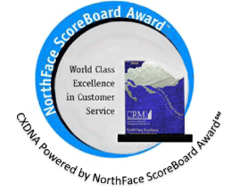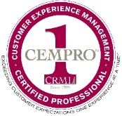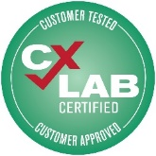  To Sponsor BCfL webcast contact:  Diane Rivera, email: drivera@crmirewards.com | phone: 978-710-3269. | 