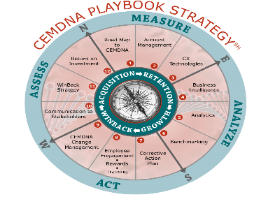
Exceeding Customer Expectations – One Experience at a Time℠
P. O. Box .323, Chelmsford, Massachusetts 01824
Tel: 978-710-3278 / www.crmirewards.com

Account Management Profile Snapshot Audit

How often do the following activities occur within your company?
1 = Never | 2 = Occasionally | 3 = Usually | 4 = Frequently | 5 = Always
The company has a well-defined set of customer segments that includes Accounts (Tier I – Tier II – Tier III) and Contacts (Decision Maker – Recommender – Influencer)
Customer feedback from all customer touchpoints is collected, analyzed, dispersed throughout the company
Customer feedback is integrated throughout key processes product development – marketing – customer service
Customer satisfaction benchmark metrics are reviewed and treated as importantly as financial metrics
Customer feedback is reviewed and acted upon
Category #1: SEGMENTATION/ SURVEY / BENCHMARK Total

Employee perception of customer satisfaction/loyalty is compared to actual customer ratings
A meaningful portion of employee compensation is based on customer satisfaction / loyalty ratings
The company provides ongoing customer relationship certified training for employees
The company celebrates, and rewards employees based on customer satisfaction / loyalty ratings
Human Resources actively gathers employee feedback and acts upon the results
Category #2: EMPLOYEE ENGAGEMENT

The company has formal frequently schedule review of corrective action results
The company establishes an easily understood corrective action process
The company establishes an easily understood set of support standards
The company surveys customers and utilizes analytics to identify the key performance indicators
The company annually reviews / revises their support standards
Category #3: CORRECTIVE ACTION / CX ANALYTICS / SUPPORT STANDARD Total

The company seeks independent 3rd party Validation / Recognition of providing exceptional customer service
The company uses Customer Bill of Rights methodology to guide employees in customer financial decisions that will result in increased customer loyalty
The Chief Customer Officer regularly reports customer feedback / corrective action results to the President / CEO and executive staff
The company agrees to provide goods and services that will consistently exceed their customer’s expectations and to provide their employees a workplace which motivates and where employees are trained and skilled in customer relationship, customers are valued, and relationships are maximized
A meaningful portion of executive compensation is based on customer satisfaction / loyalty ratings
Category #4: INDEPENDENT 3RD PARTY VALIDATION – RECOGNITION / CUSTOMER BILL OF RIGHTS Total

The company conducts internal reviews to determine how to maximize the value of your products / services to the customer
The company recruits AMP team members who are responsible for identifying how to maximize the value of our products / services resulting in financial benefits to the customer
The company identifies value added benefits (decreased costs - increased productively – increased revenue – technology leadership – etc.) to the customer
The company conducts formal customer partnership reviews and identifies CSAT levels – corrective action – value added benefits provided both current and past 12 months of history
The customer is asked to rate the level of satisfaction with our partnership contribution as to maximizing the value of our products/services resulting in financial benefits to the customer
Category #5: PARTNERING 4 SUCCESS Total
Overall Category Totals
Individual Category Competency Totals:  5 to 10 Failure  11 to 14 Poor  15 to 19 Average  20 to 25 Excellent | Overall AMP Rating: All five (5) categories  Less than 50 Non-Existent AMP Strategy  50 to 59 Very Low  60 to 84 Reactive  85 to 99 Engaged  100 to 125 AMP Centric – Key part of Company’s DNA

Please select the industry segment that best fits your company

- Telecommunications | - Financial Services | 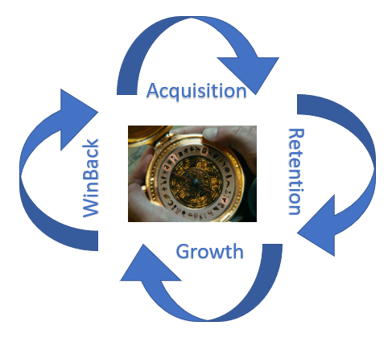
- Medical Hardware | - Retail / Hospitality/ Real Estate
- Medical Suppliers | - Hospital / Clinics
- Medical Services / Healthcare | - Transportation
- Semiconductor | - Waste Management Services
- Computer Software | - Bio Tech / Life Sciences
- Computer /Peripherals/ Wireless | - Internet / Mobile Technology
- Analytical Device Equipment | - Pharmaceuticals
- Test / Measurement Equipment | - Entertainment
- Energy / Utilities | - Chemical / Packaging
- Construction | - Other ________________

